**School of Computer Science**

**UNIVERSITY OF PETROLEUM AND ENERGY STUDIES**

**DEHRADUN, UTTARAKHAND**



**ADVANCE DATABASE**

**MANAGEMENT SYSTEM LAB**

**EXPERIMENT 2 File**

**Submitted By:**

Akshat Negi

500106533

Batch 2

**Submitted To:**

**Asst. Prof. Kotha Venugopalachary**

**SoCS, UPES**

EXPERIMENT-5

Title: 5. Use of different SQL clauses and join

Objective: To understand the use of group by and having clause and execute the SQL commands using JOIN

### **1.** Write the SQL Queries for the following queries (use emp_table and dept_table of Experiment 4).

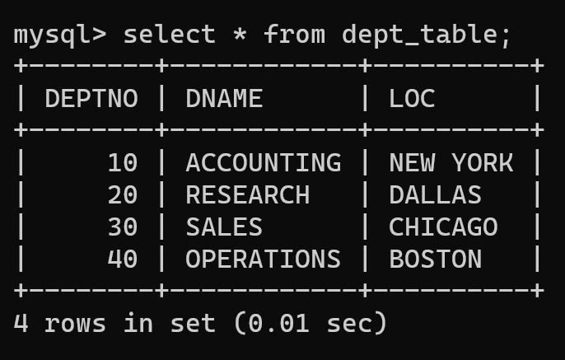

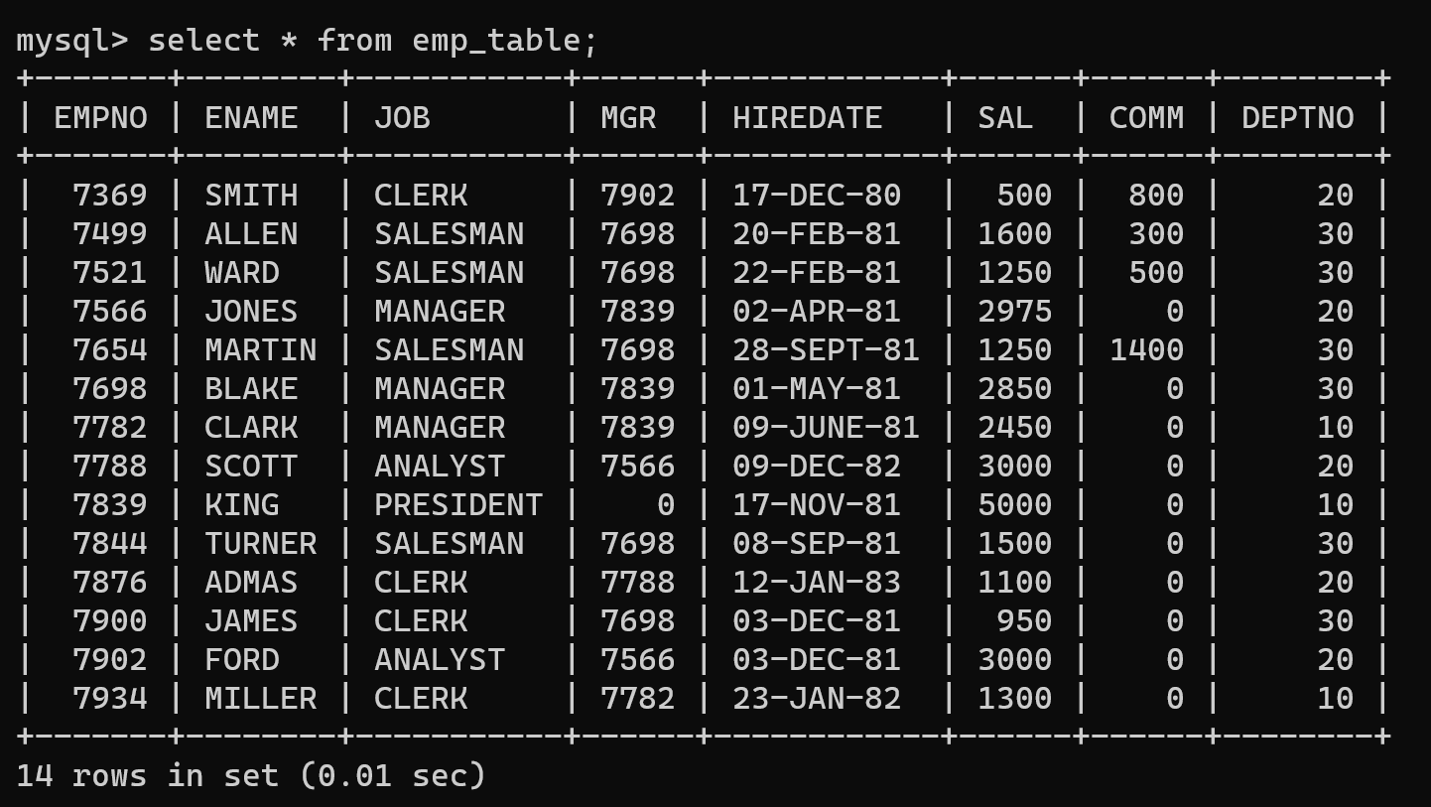

1. List the Deptno where there are no emps.

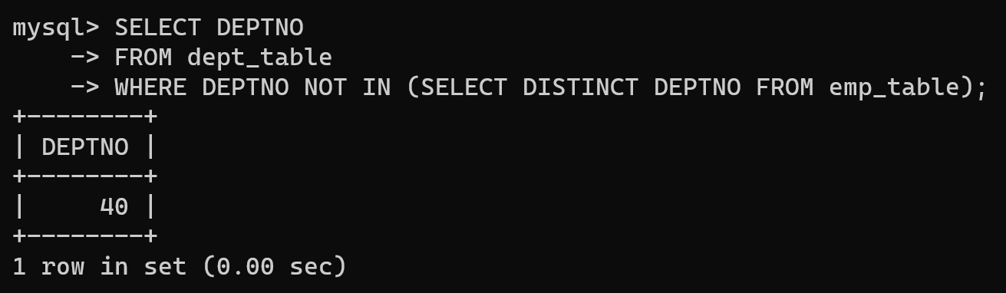

2. List the No.of emp’s and Avg salary within each department for each job.

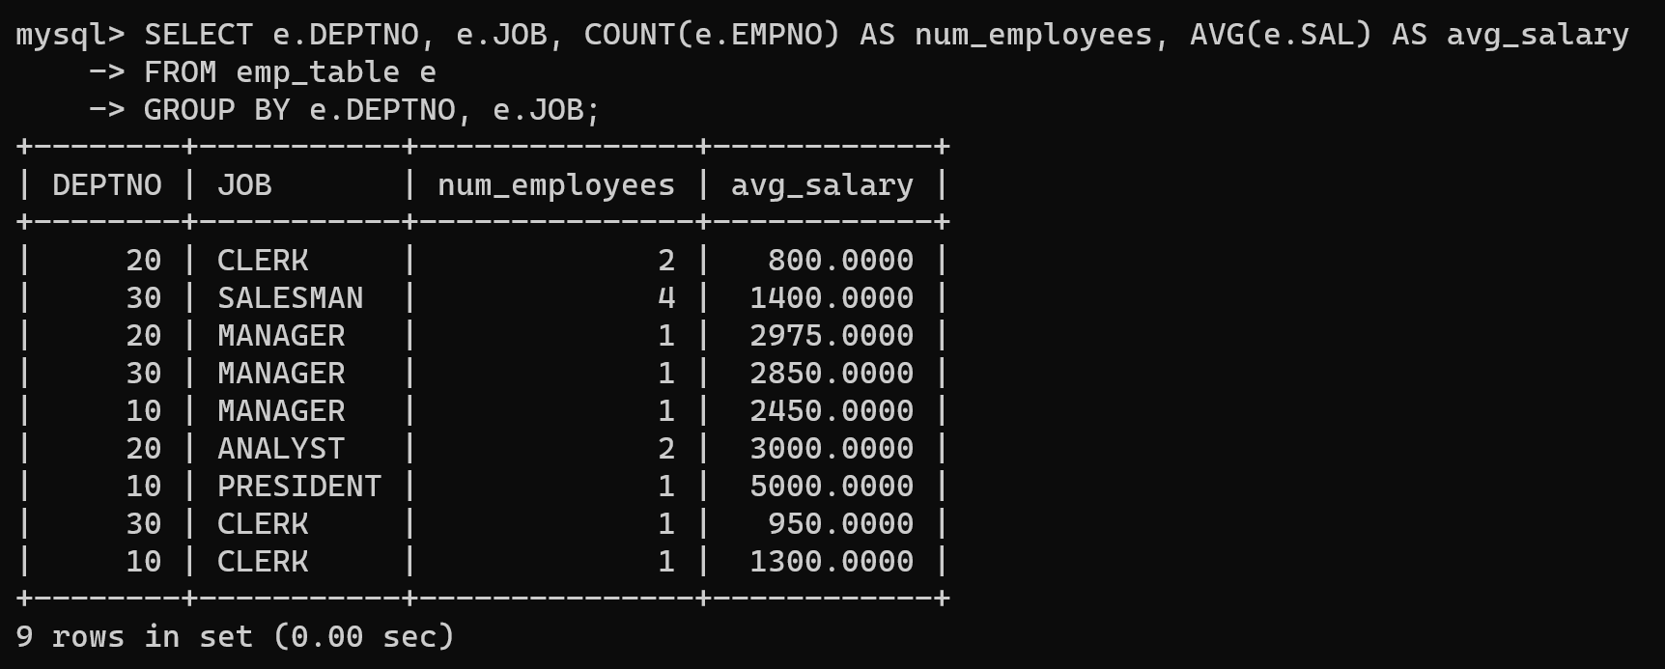

3. Find the maximum average salary drawn for each job except for ‘President’.

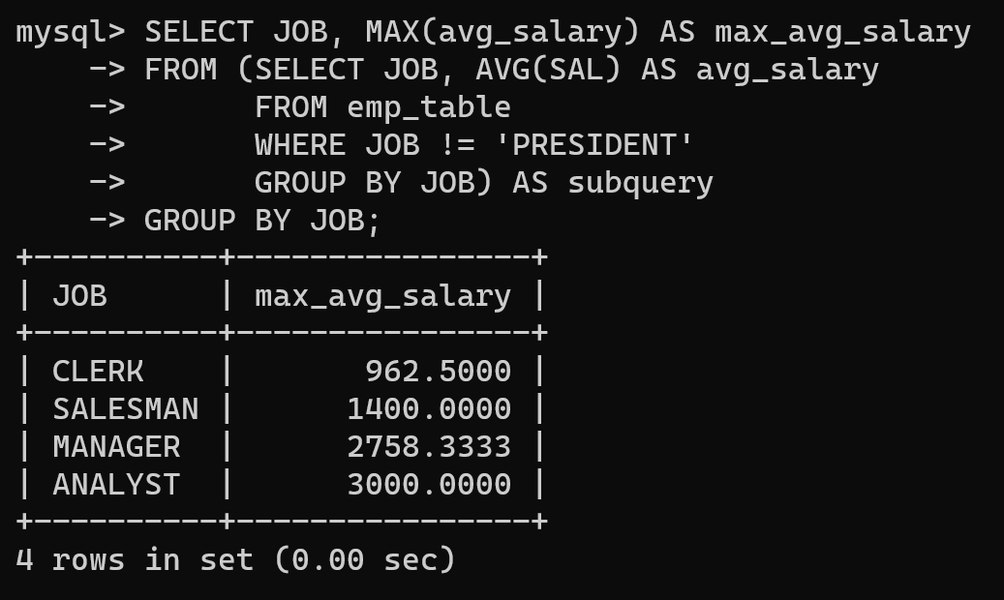

4. List the department details where at least two emps are working.

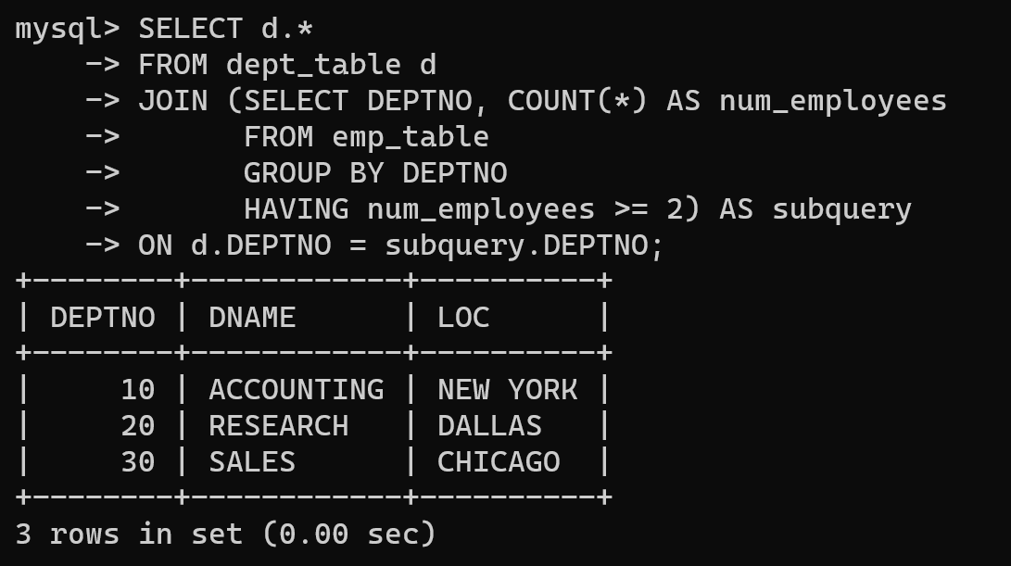

5. List the no. of emps in each department where the no. is more than 3.

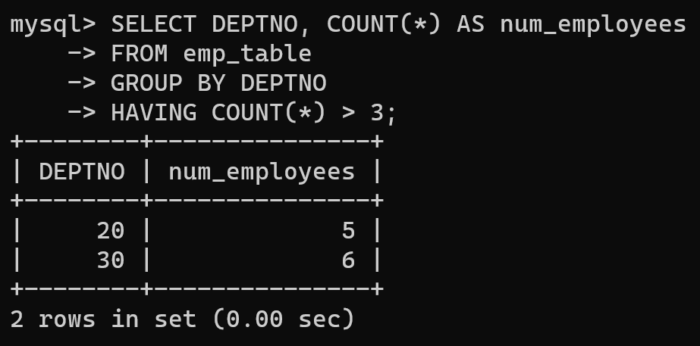

6. List the names of the emps who are getting the highest sal dept wise.

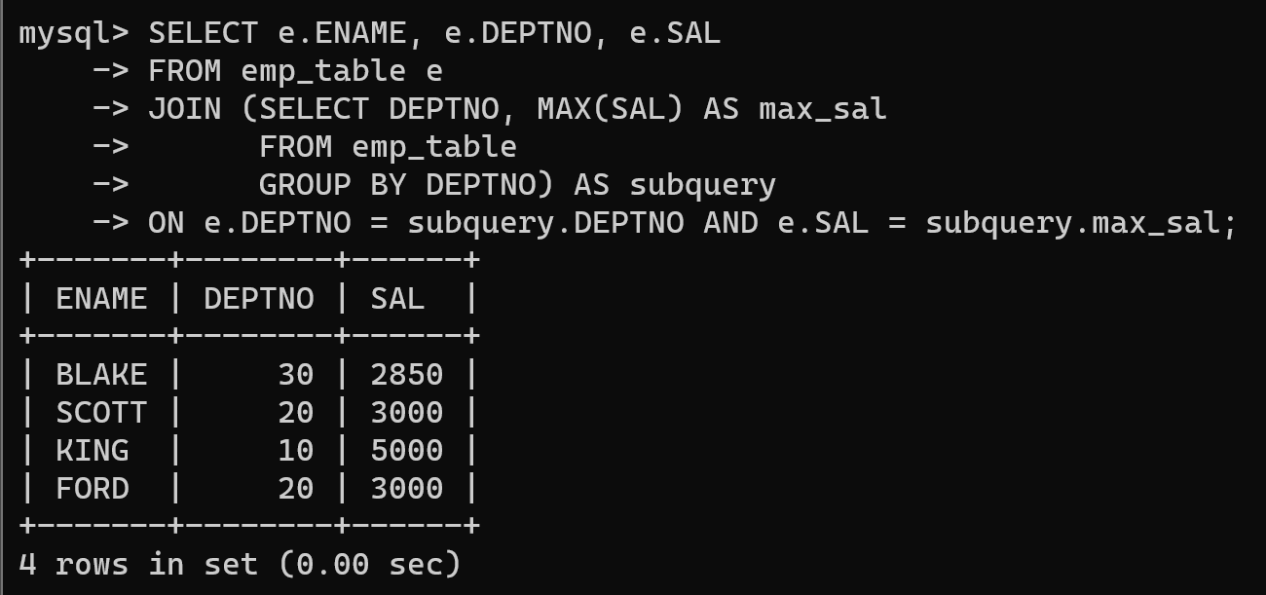

7. List the Deptno and their average salaries for dept with the average salary less than the averages for all departments.

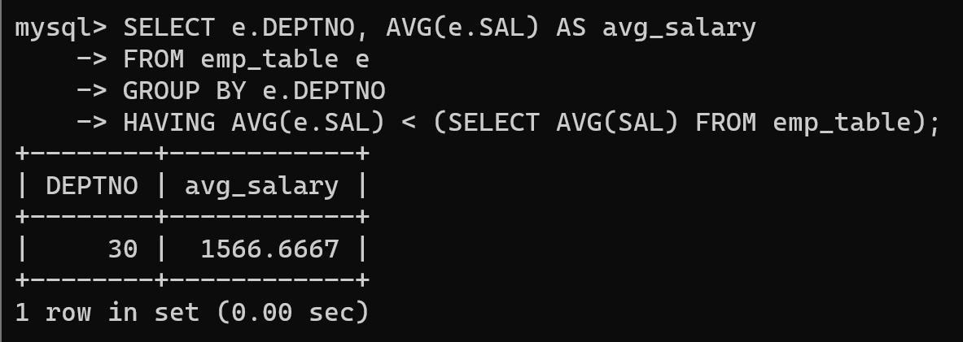

### **2.** Execute experiment 4 using sql join.

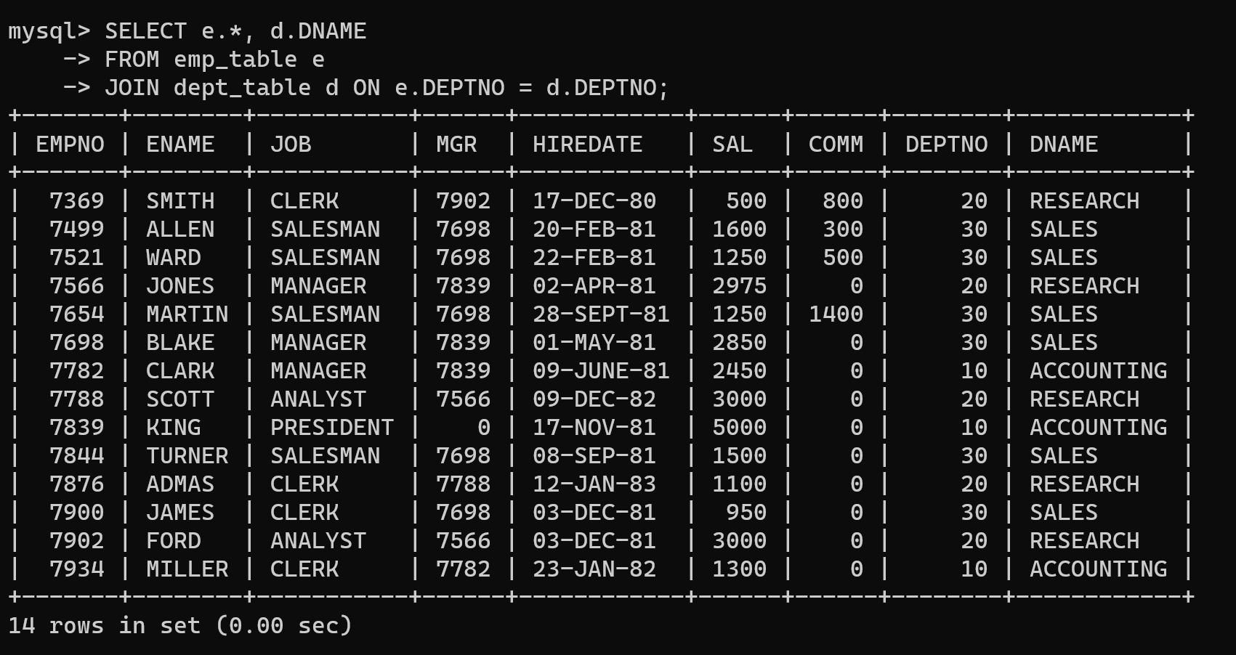

2.1 List the details of the emps whose Salaries more than the employee BLAKE.

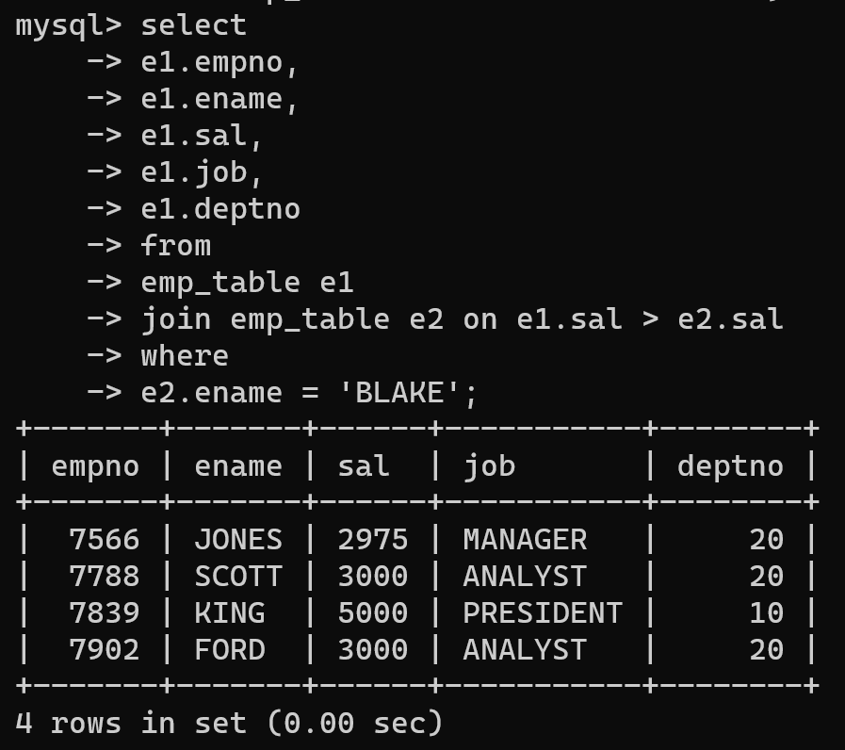

**1. σ(EMPNO, ENAME, JOB, MGR, HIREDATE, SAL, COMM, DEPTNO)(EMP_TABLE ⨝ EMP_TABLE.SAL > BLAKE.SAL)**

**2. σ(EMPNO, ENAME, JOB, MGR, HIREDATE, SAL, COMM, DEPTNO)(EMP_TABLE ⨝ ENAME = 'BLAKE')**

2.2 List the emps whose Jobs are same as ALLEN.

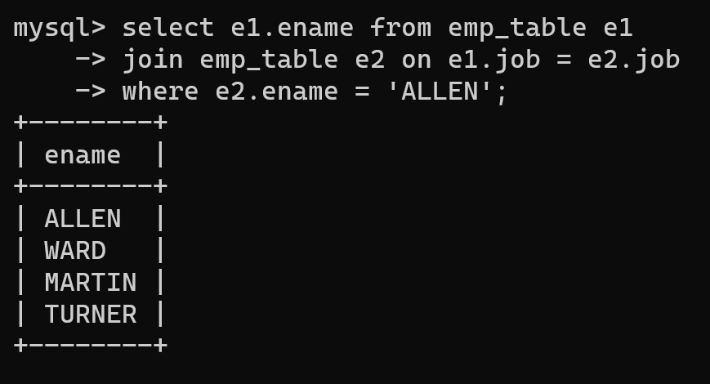

**1. σ(EMPNO, ENAME, JOB, MGR, HIREDATE, SAL, COMM, DEPTNO)(EMP_TABLE ⨝ EMP_TABLE.JOB = ALLEN.JOB)**

**2. σ(EMPNO, ENAME, JOB, MGR, HIREDATE, SAL, COMM, DEPTNO)(EMP_TABLE ⨝ ENAME = 'ALLEN')**

2.3. List the Emps whose Sal is same as FORD or SMITH in desc order of Names.

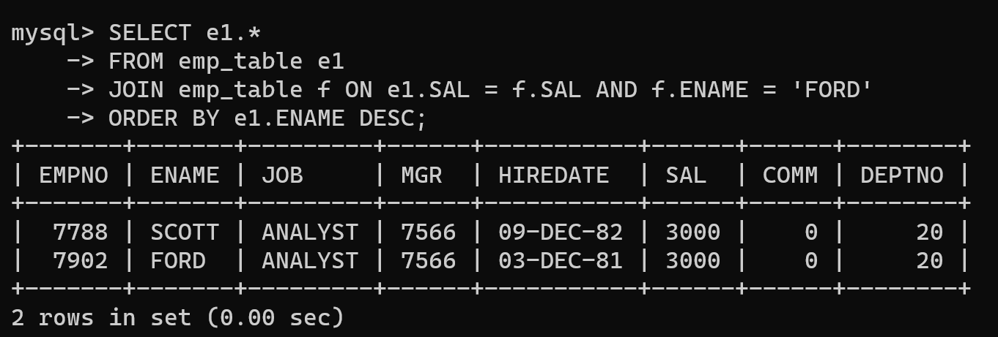

**1. π(SAL)(EMP_TABLE ⨝ ENAME = 'FORD' ∨ ENAME = 'SMITH')**

**2. ρ(subquery)(1)**

**3. π(EMPNO, ENAME, JOB, MGR, HIREDATE, SAL, COMM, DEPTNO)(EMP_TABLE ⨝ EMP_TABLE.SAL = subquery.SA**

**4. σ(EMPNO, ENAME, JOB, MGR, HIREDATE, SAL, COMM, DEPTNO)(3)**

**5. ρ(e, 4)**

**6. σ(EMPNO, ENAME, JOB, MGR, HIREDATE, SAL, COMM, DEPTNO)(e)σ(SAL DESC)**

2.4. List the emps Whose Jobs are same as MILLER or Sal is more than ALLEN.

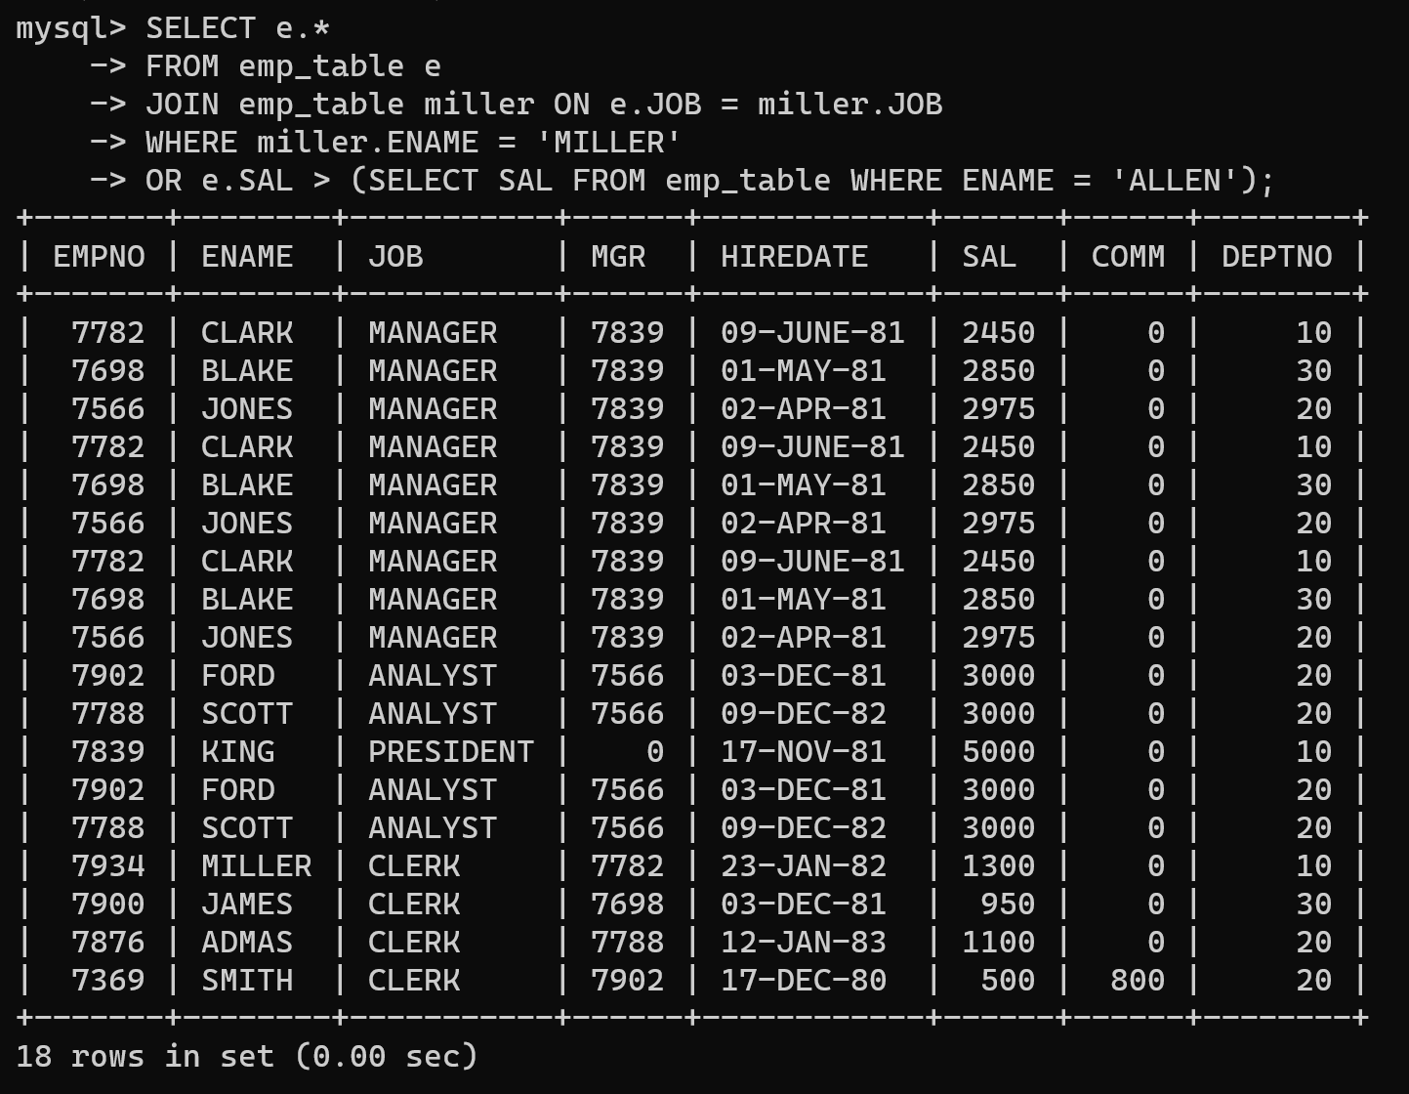

2.5. Find the highest paid employee of sales department.

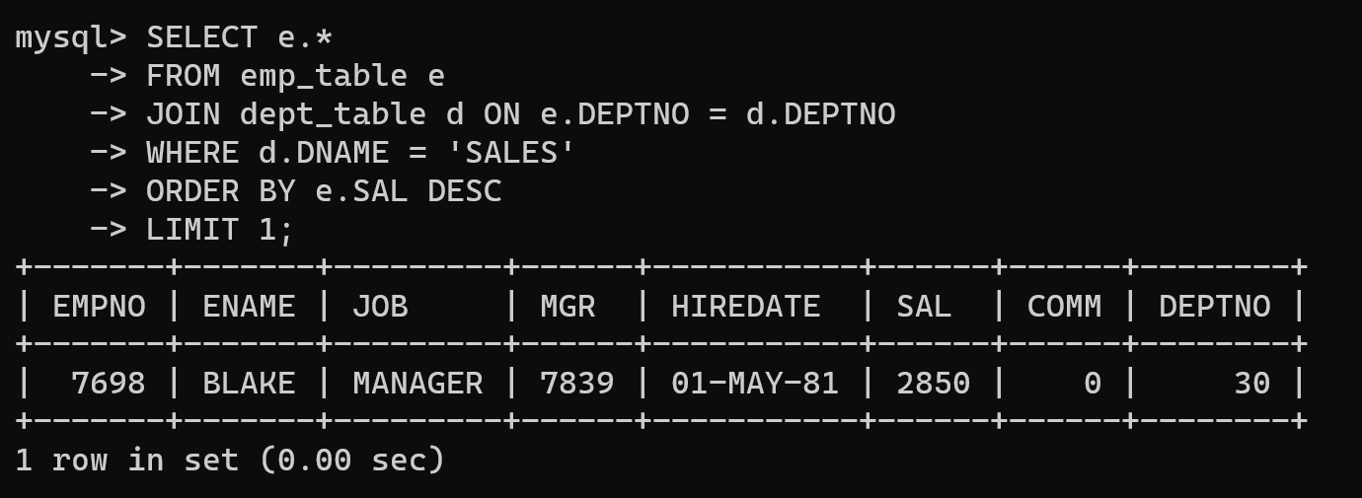

2.6. List the employees who are senior to most recently hired employee working under king.

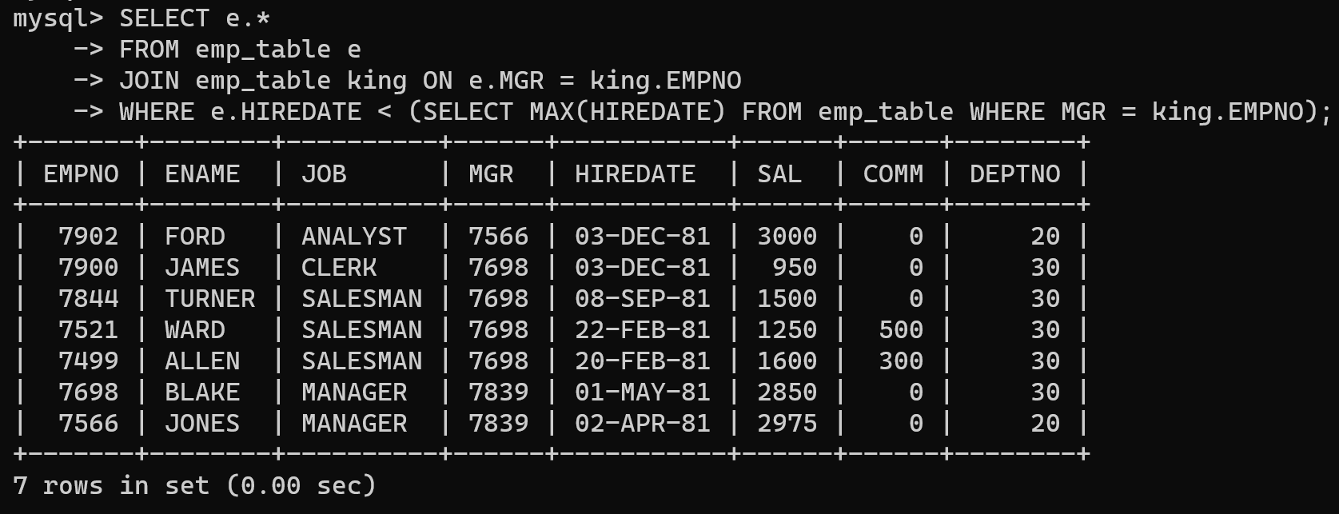

2.7. List the names of the emps who are getting the highest sal dept wise.

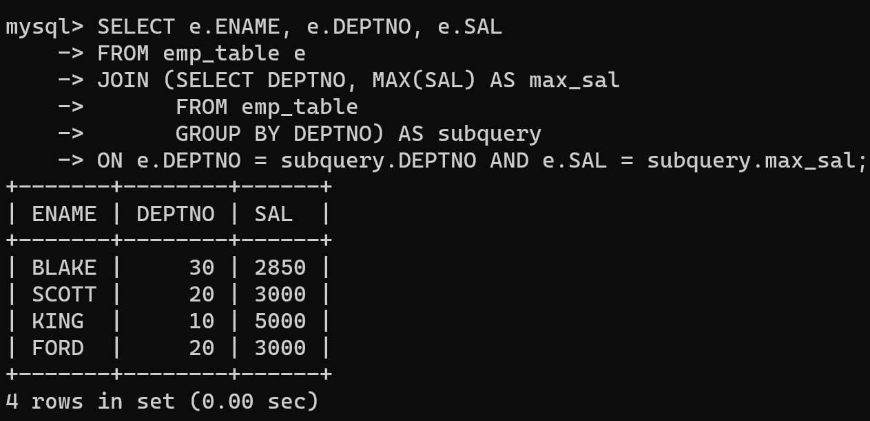

2.8. List the emps whose sal is equal to the average of max and minimum

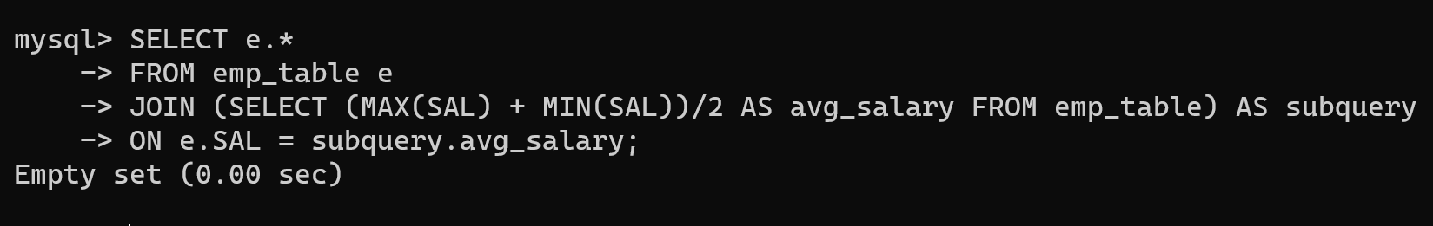

2.9. List the emps who joined in the company on the same date.

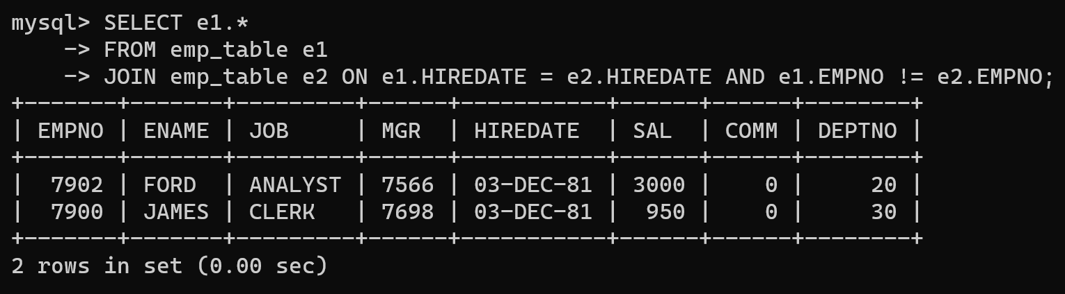

2.10 Find out the emps who joined in the company before their Managers.

